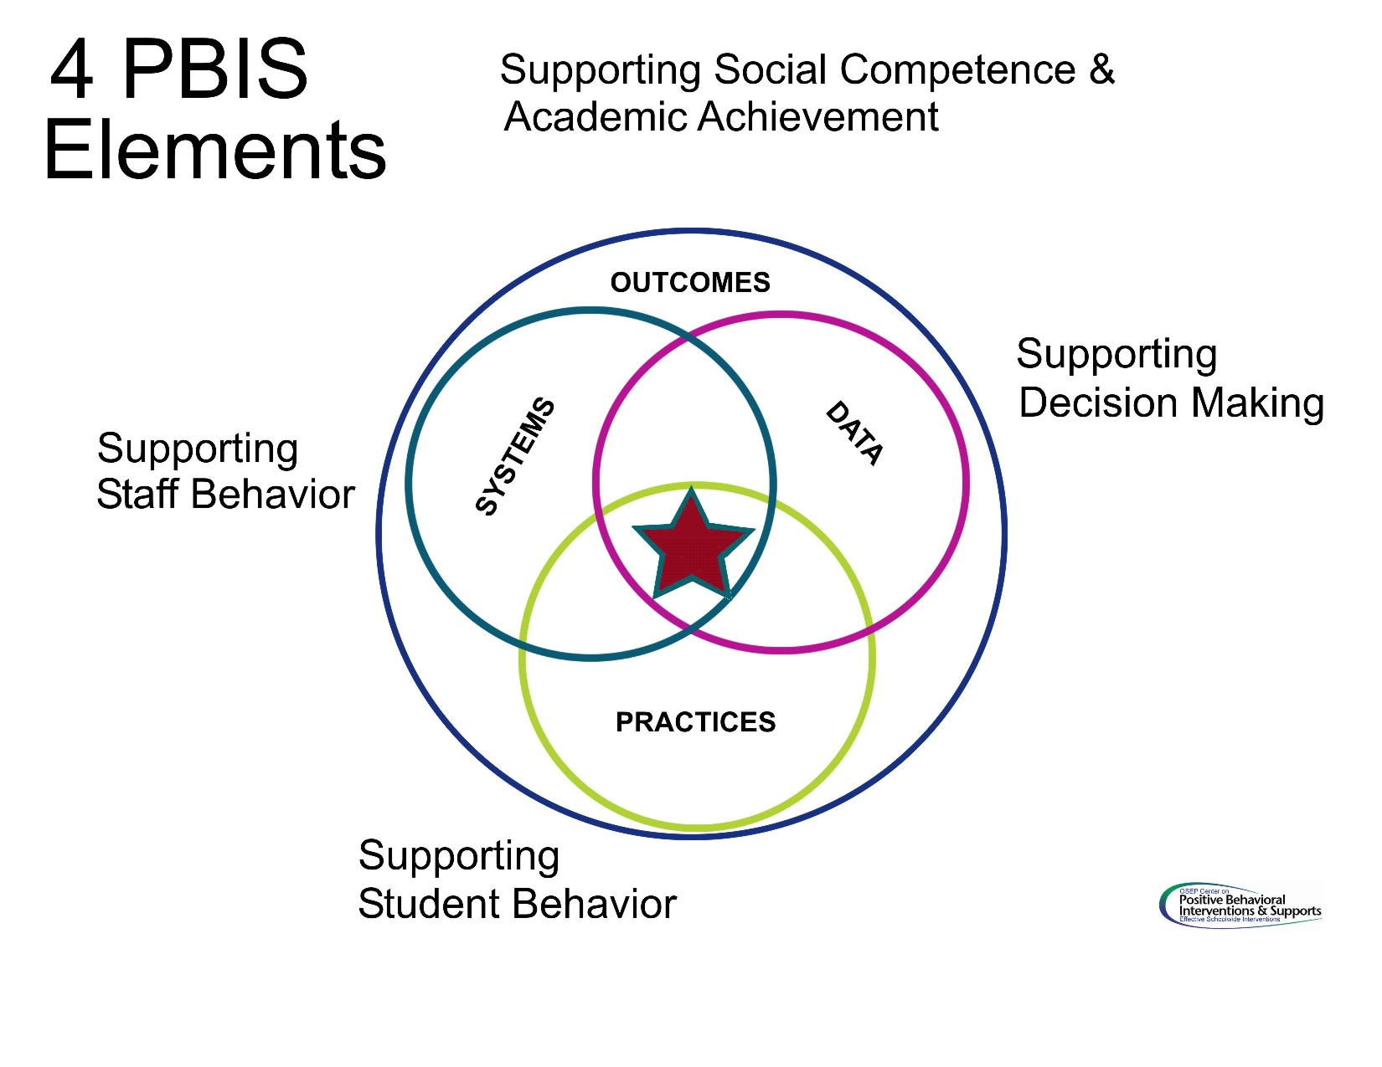

**Kris Chryst, Elementary Principal**

[kchryst@eastcentral.k12.mn.us](mailto:kchryst@eastcentral.k12.mn.us)

**Katie Goulet, School Psychologist**

[kgoulet@scred.k12.mn.us](mailto:kgoulet@scred.k12.mn.us)

**Martha Diggan, Kindergarten**

[mdiggan@eastcentral.k12.mn.us](mailto:mdiggan@eastcentral.k12.mn.us)

**Stephanie Skalicky, 1st Grade**

[sskalicky@eastcentral.k12.mn.us](mailto:sskalicky@eastcentral.k12.mn.us)

**Jennifer Klocke, 2nd Grade**

[jklocke@eastcentral.k12.mn.us](mailto:jklocke@eastcentral.k12.mn.us)

**JacLynn Cavallin, 3rd Grade**

[jcavallin@eastcentral.k12.mn.us](mailto:jcavallin@eastcentral.k12.mn.us)

**Amy Schmitz, 5th Grade**

[aschmitz@eastcentral.k12.mn.us](mailto:aschmitz@eastcentral.k12.mn.us)

**Jamie Stone, Music Teacher**

[jstone@eastcentral.k12.mn.us](mailto:jstone@eastcentral.k12.mn.us)

**Darrin Kvam, ADSIS Coordinator**

[dkvam@eastcentral.k12.mn.us](mailto:dkvam@eastcentral.k12.mn.us)

**Dawn Fjosne, Paraprofessional**

[dfjosne@eastcentral.k12.mn.us](mailto:dfjosne@eastcentral.k12.mn.us)

## Our PBIS Team:

The PBIS team

would like to thank you for taking the time to read about our new program & supporting us! If you have questions, please feel free to contact the PBIS Team.

**A Guide to PBIS:**

East Central Elementary School

Help teach your child the importance of being *Respectful, Responsible,  
 & Ready to Learn*

Keep in touch with your   
child’s teacher

Take part in the instruction & reinforcement systems if your child is part of a classroom or individual intervention program

Volunteer in school activities

Support by teaching & encouraging expectations in home & community settings

Be consistent with rewards & consequences

**And most importantly…**

Celebrate your child’s successes!

61085 State Hwy 23

Finlayson, MN 55735

320.245.2289

### **Ways to Help Your Child Stay on the Path to Positive Behavior:**

Positive

Behavior

Intervention

&

Supports

Positive Behavior Intervention & Supports

**What is Positive Behavior Intervention & Supports? (PBIS)**

PBIS is a school-wide framework for promoting positive behavior and a safe environment for all students. There are 3 main components of PBIS: 1) teaching appropriate behavior, 2) celebrating students when they meet behavior expectations, and 3) providing interventions for students who need further support. Our school’s behavioral expectations center on the ideas of being **Respectful**, **Responsible**, and **Ready to Learn**. PBIS aims to help all students succeed academically, behaviorally, socially, and emotionally.

# Classroom Expectations

# Eagle Pride =

*Be Respectful*

* Use appropriate voice level
* Use body basics
* Treat property with care
* Be kind

*Be Responsible*

* Be on time
* Complete daily jobs/work
* Clean up after yourself
* Work well with others
* Tell the truth

*Be Ready to Learn*

* Follow directions
* Be prepared
* Take turns

Students can earn Eagle Pride slips from staff for demonstrating positive behaviors throughout the school day! They can receive slips from all staff in the school, including bus drivers and paraprofessionals.

The PBIS Team sets school-wide goals for Eagle Pride slips. Once the students meet the Eagle Pride slip goal, they receive a celebration, such as extra recess, Hawaiian pool party, or bowling!